Ideation Phase
Define the Problem Statements

Date | 29 JAN 2026
Team ID | LTVIP2026TMIDS39173
Project Name | ToyCraft Tales: Tableau's vision into toy manufacturer data
Maximum Marks | 2 Marks

Customer Problem Statement Template:
Create a problem statement to understand your customer's point of view. The Customer Problem Statement template helps you focus on what matters to create experiences people will love.

Problem  Statement (PS) | I am  (Customer) | I’m trying to | But | Because | Which makes me feel
PS-1 | A toy company manager | Understand toy sales and product trends | The raw data is complicat ed and unclear | There’s no easy way to visualize the data efficiently | Frustrated and unsure about decisions
PS-2 | A supply chain executive | Manage toy inventory effectively | I can't track stock levels clearly | The reports are outdated and lack visual insights | Worried about overstock or shortages

A well-articulated customer problem statement allows you and your team to find the ideal solution for the challenges your customers face. Throughout the process, you’ll also be able to empathize with your customers, which helps you better understand how they perceive your product or service.

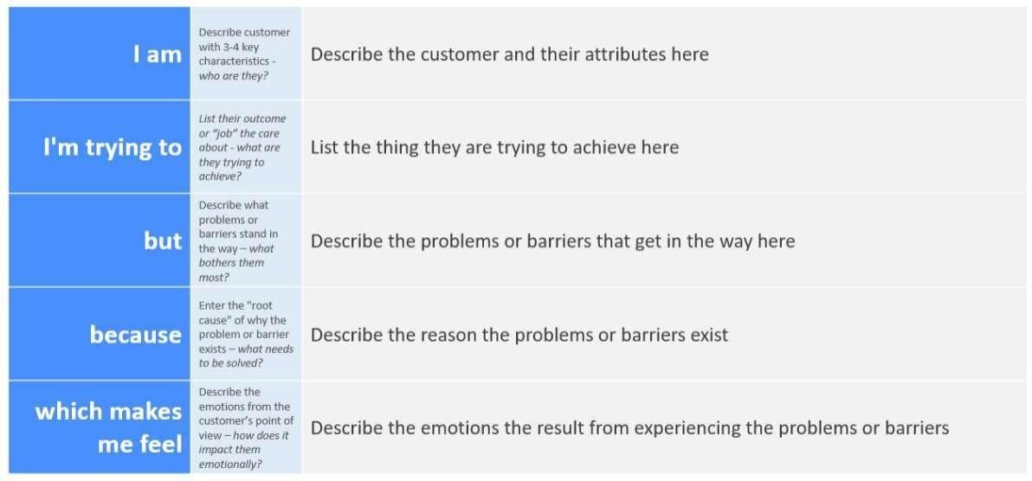
Reference: https://miro.com/templates/customer-problem-statement/
Example:

2.2 EMpathy map

